2024 | Multifamily Market Report | Orange County, CA
Share
Orange County Apartment Market Report
- The Orange County apartment market is among the nation’s 50 major markets, is has the second lowest vacancy rate at 4.1%
- Absorption reached roughly 2,200 units in 2024, up from 2023 but lower than the previous decade’s annual average of 2,900 units.
- Demand is robust with continued job growth, improved affordability, and an increase in international immigration.
By the Numbers | Orange County Apartments
2024 | Source: CoStar Group
Sales Volume: $1.5B
Market Sale Price Per Unit: $439K
Cap Rate: 4.4%
Vacancy Rate: 4.1%
Rent Growth: 0.2%
Average Market Asking Rent per Unit: $2,695
Under Construction: 5,301 Units
Delivered: 2,837 Units
Absorbed: 2,221 Units
Orange County Demographics
Unemployment Rate: 4.2%
Current Population: 3,144,028
Households: 1,098,588
Median Household Income: $116,253
The Walt Disney Company is Orange County’s largest employer, with a projected workforce of approximately 36,000 people.
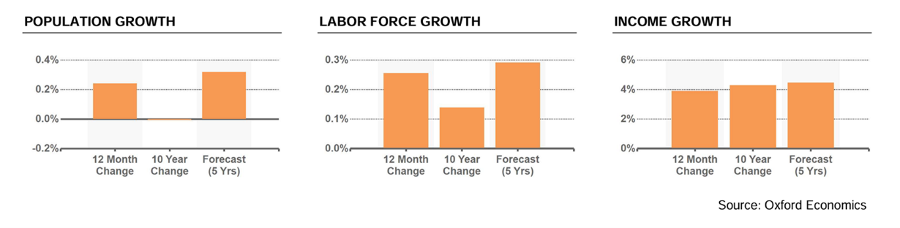
Orange County Apartment Performance
Among the nation’s 50 major markets, the Orange County apartment market has the second lowest vacancy rate at 4.1%. Although it still compares favorably with other markets, vacancies have increased in the market, especially in Class A assets. As a result, rents growth has remained relatively flat, recording 0.5%. Based on current developments, supply will climb to roughly 4,700 units by 2025. However, if employment grows as expected, absorption will at least maintain its current rate, if not accelerate, causing market vacancy to decrease. Stronger absorption should allow landlords to increase rent growth in the coming year.
Performance by Class
 | Units | Vacancy Rate | Asking Rent
Class A | 75,976 | 5.9% | $3,246
Class B | 88,021 | 3.6% | $2,673
Class C | 95,909 | 3.1% | $2,074

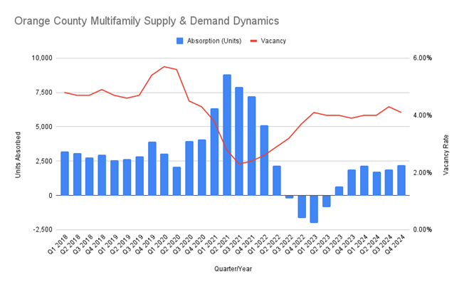
Orange County apartment development remains limited due to land constraints and, at times, difficult approval processes. For example, a 500-unit Anaheim Hills development was denied in November 2024 owing to concerns over density and wildfire evacuation. A few major developments will open in Anaheim and Santa Ana in 2024. Cypress and Laguna Niguel both experienced rare supply additions. However, development is historic and continues to be centered in the booming city of Irvine, where more than 4,000 apartments are under construction and will be delivered in the next few years.
Despite a nationwide slowdown in sales activity caused by increased interest rates and tighter credit conditions, Orange County’s apartment market remained resilient. In 2024, approximately 150 transactions were completed, up 20% from the low of 2023 but still significantly below historical averages, while sales volume increased marginally to $1.4 billion.
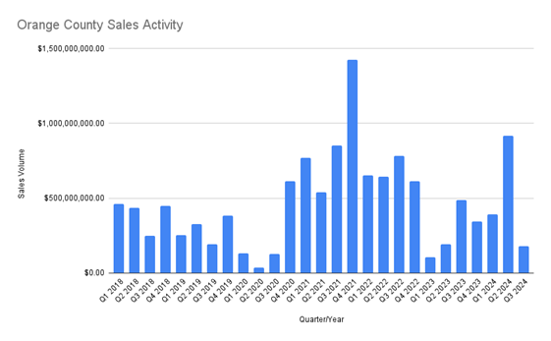

Submarket Highlights
Submarket | Average Rent/Unit | Annual Rent Growth | Vacancy Rate | 12-Month Units Absorbed | Units Under Construction | 12-Month Sales Volume | Avg Price/Unit
Anaheim | $2,280 | 2.0% | 4.8% | 121 | 0 | $397M | $370K
Central OC East of I-5 | $2,538 | 2.2% | 3.7% | 179 | 0 | $194M | $409K
Central OC West of I-5 | $2,358 | 1.5% | 3.6% | 454 | 326 | $368M | $389K
Costa Mesa | $2,647 | 1.9% | 3.6% | 177 | 0 | $65.3M | $431K
Huntington Beach/Seal Beach | $2,658 | -0.1% | 3.3% | 30 | 380 | $95.8M | $475K
Irvine | $3,261 | -1.7% | 4.2% | 766 | 4,197 | $248M | $550K
North County | $2,376 | 1.9% | 4.2% | 257 | 380 | $132M | $385K
South County | $2,933 | 1.0% | 5.4% | 170 | 18 | $54.4M | $475K
Newport Beach | $3,593 | -0.7% | 2.4% | 53 | 0 | $12.2M | $547K
Tustin | $2,578 | 0.2% | 3.3% | (59) | 0 | $5.7M | $390K
Anaheim
Rent growth has decreased in recent years, falling from a record 10% annual gain in 2021 to 1.9% over the previous year. Higher lending rates have slowed sales activity, which is currently driven by smaller transactions. Over the previous year, vacancy has trended evenly among stabilized assets, excluding new buildings under lease-up, at slightly less than 3.5%. Anaheim is a working-class city with a large concentration of inexpensive housing. Many renters in the neighborhood work at Disneyland, the city’s main employer, or in other low-wage service, hospitality, or industrial sectors. As a result, the demand for Class B & C apartments in the neighborhood remains high.
Central OC East of I-5
While vacancy in the Submarket has historically trended higher than the Orange County apartment market average over the last decade, it has maintained positive absorption in recent years, resulting in vacancy falling below the market average in the third quarter of 2024. The area’s apartment rents continue to rise gradually due to strong demand. Rent growth during the previous year was 2.6%, compared to the 0.7% market average. Rent increase in Orange County apartment submarkets has consistently exceeded the national average, owing to a halt in housing development.
Central OC West I-5
A flood of deliveries in 2023, following an outflow of tenants in 2022, increased the submarket’s total vacancy rate to a high of 5.4% in mid-2023. Since then, as new properties have leased up, the vacancy rate has trended lower and now stands at 3.6% as of Q1 2025. Complexes recently completed in 2023 and 2024 have increased competition for high-quality apartment renters while reducing the under-construction pipeline to 330 units. In recent years, median income levels have risen faster than market rents, resulting in increased affordability and a return to positive net absorption in the last four quarters.
Costa Mesa
Rent levels dropped from the middle of 2022 to the first quarter of 2023 but are presently rising again as demand grows heading into 2025. As of the first quarter of 2025, trailing-year rent increase was moderate at 2.0%, but it has recently decelerated. Costa Mesa’s apartment absorption rate remained positive. Vacancy increased in the second quarter of 2024 due to the delivery of a new 200-unit complex, but it is expected to fall further in future quarters as the complex’s occupancy stabilizes.
Huntington Beach/Seal Beach
Despite their old age and wear, beachfront apartments fetch high rental rates and frequently sell at low cap prices. Overall, rents in the submarket are slightly higher than the market average. Huntington Beach/Seal Beach is a preferred region for apartment tenants due to its miles of coastline, numerous entertainment events, and restaurants, all of which are a convenient commute from Irvine or downtown Orange County. As a result, vacancy in the submarket has remained below the market average since 2019, currently standing at 3.3%.
Irvine
Irvine is by far the most active place for apartment development in Orange County, thanks to remaining available land sites and redevelopment projects. Over the last five years, approximately 1,100 units have been delivered, increasing the area’s apartment supply by 7.7% to 43,000. Strong demand has aided ongoing construction. Vacancy rose in the third quarter due to supply additions but remains at a compressed 4.2% as of the first quarter of 2025. Absorption is projected to remain positive due to persistent job and apartment inventory growth.
North County
The North County Submarket includes the cities of Los Alamitos, Cypress, Buena Park, Fullerton, La Habra, and Brea, and its apartments are primarily rented by blue-collar workers. Lower-grade Class C buildings account for more than half of the area’s apartment stock, while Class A inventory is limited to 12% or approximately 4,500 units. As of the first quarter of 2025, vacancy rates were 4.2%, which is close to the market average of 4.1%. Vacancy is expected to drop in the coming quarters as renters move into the new supply. No additional inventory increases will be made until mid-2025.
South County
South County’s apartment vacancy rate is 5.3% as of the first quarter of 2025, a slight decrease from its historical average of 5.4%. Absorption was negative in the first two quarters of 2024, and a recent delivery increased vacancy—although absorption is reducing vacancy heading into 2025. Overall, little supply has been built in the area since the pandemic began. Construction is more common in central Orange County, where there is more developable land and redevelopment opportunities. As builders go east into the Saddleback foothills and ranch acreage, single-family houses are becoming increasingly prevalent in South County housing.
Newport Beach
Newport Beach is a prosperous community, with over 40% of its 9,300-unit housing supply housed in high-quality Class A buildings. The area’s average market rents are 7% higher than those in Irvine, reflecting the excellent position near the ocean. Absorption was negative from 2022 to 2023 but has since turned positive. As a result, vacancy is decreasing and stands at a compacted 2.4% in the first quarter of 2025. Despite improving market conditions, market rents fell by 0.3% over the previous year.
Tustin
Tustin is a favored region for apartment renters due to its affordability, outstanding schools, safety, and close proximity to Irvine offices. Tustin’s vacancy rate has consistently been lower than the market average, and it continues to remain so. Nonetheless, absorption has measured at -48 units over the previous year. Vacancy is increasing owing to occupancy loss, however, it remains at a compacted 3.3% as of the first quarter of 2025. Tustin comprises approximately 9,900 apartment units. Mid-quality Class B structures account for over 55% of inventory, with Class C buildings accounting for approximately 34%.

